# **Comparison of Population Survey Methods of**

# **White-Tailed Deer**

**Abstract** As land managers and conservationists, one of the first steps we take to manage white-tailed deer (*Odocoileus virginianus*) is to survey the current population size. Numerous surveying methods are used throughout the United States; however, spotlight surveys are commonly used to determine population dynamics and size due to the ease of this method and the lack of resources it requires of the land manager. Recently, our company conducted a spotlight survey of white-tailed deer on a land owner’s property and found that our results were not coherent with the actual current population densities found on the property. It is because of this that we decided to provide a document that compares different population survey methods commonly used by researchers. Our goal of this article is to provide the reader with a basic understanding of how to conduct several population surveying methods of white-tailed deer. The following research provides a comparison of spotlight surveys to other population survey methods used by researchers.

**Big Tine Consulting Inc.**

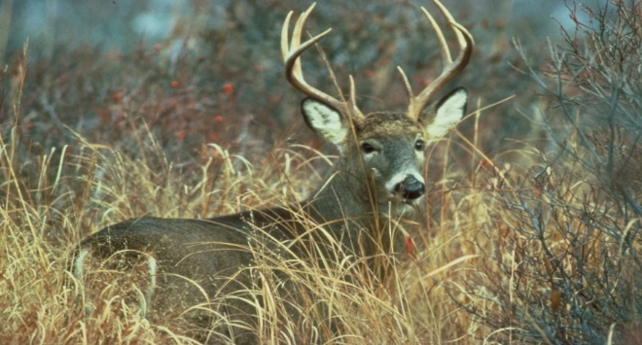

**Introduction** Population dynamics of white-tailed deer are important to evaluate in order to manage the health of deer herds on your property. People predominantly perform road spotlight surveys in comparison to camera surveys, aerial surveys, and fecal pellet counts because of the ease and the lack of expensive resources required to complete the survey. Road spotlight counts have been used for years in order to determine the population of white-tailed throughout the country. It is important to determine the population dynamics of a property in order to provide the deer with an adequate amount of forage and cover. Understanding the population density on a given property allows the landowner to predetermine the amount of deer that need to be harvested off of the property to ensure a healthy herd exists. An overabundance of white-tailed deer on a property results in deer competing for food, which can reduce plant diversity. Understanding how to implement different population survey methods on a given property and their reliabilities is important for managers to determine before they survey their white-tailed deer populations. The following information discusses four population survey methods of *Odocoileus virginianus*.

**Camera Surveys** Camera surveys are used by many wildlife researchers and are the second most common way people survey deer densities on a property. This survey method is relatively inexpensive when compared to other surveys such as aerial surveys. The cameras have a long duration time and can capture deer day and night. In order to perform camera surveys, the landowner must strategically place cameras on trails, food sources, and bedding areas in order to effectively capture deer. When using the camera survey method, it is important to refrain from bias sampling. Infrared-triggered cameras (ITCs) allow the deer to be captured without alerting or spooking off other deer and allows the landowners to accurately capture deer movement. These cameras are compact and easy to use, which allows the user to set them up quickly. When 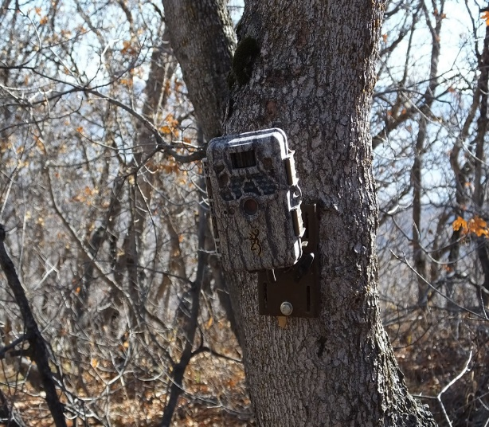placing cameras to survey the population, it is important to create a randomized sample design to eliminate bias. When compared to Road spotlight surveys, there are major differences in accuracies.

A study conducted by several researchers from Texas A&M eluded to these differences in a study that compared camera and road spotlight surveys of white-tailed deer in the Florida Keys. Their research suggests several factors that contributed to the difference in population densities found in the two methods. In addition, their research indicated a difference in accuracies. Their data indicated a strong bias that was associated with road survey counts as well as a lower deer density in the observed Florida islands. While road counts are easy to implement, they result in a biased sample. Most road spotlight surveys are conducted from urban roads which result in bias because the data collected only resembles the population near roadways.

Camera surveys, however, result in a much more uniform sample because they can be placed strategically around a property and provide a more accurate sample without implementing bias. Not only does bias exist from the convenient routes on urbanized roads, but it also comes from deer habits as well. Depending on the area being studied, deer often feed near roadways because the edges of the roadways are mowed and provide deer with consistent food sources. The deer will feed on these edges until they hear an approaching vehicle. While some deer may not be affected by the passing vehicles, many deer often retreat into the tree line until the vehicle has passed. This becomes problematic when trying to accurately evaluate a population from roadways. This can create a lower deer density estimate which can negatively affect the management implementations by the landowner. Camera Survey methods allow researchers and landowners to observe deer populations even in remote areas where vehicles cannot gain access too. Even though camera surveys provide a more accurate sample, they can also create bias if baited sites are implemented. It is important when conducting camera surveys to design a plan that eliminates most if not all bias to provide a more accurate estimate of the white-tailed deer population on the property being evaluated. Overall, both road spotlight surveys and camera surveys are viable methods when trying to determine and evaluate the current white-tailed deer population on a property. While camera surveys are better for isolated remote areas, road counts can be better for properties that have roads intertwined throughout the property. Both methods are relatively inexpensive and should be considered by all managers and researchers.

**Aerial Surveys** Aerial population surveys are often conducted by researchers trying to estimate direct white-tailed deer populations. Aerial surveys consist of at least two people flying in an aircraft locating and identifying white-tailed deer. You need at least two people so that one person can locate and identify the target species, while the other can tally up the data. This population surveying method is often used by researchers and landowners that have large properties because of the large sample size. This method is used primarily on properties that have large open grasslands that consist of deciduous vegetation types. A problem with this method is that it cannot be conducted on properties with coniferous and large deciduous forests because of the lack of open spaces. This prohibits the landowners or researchers from gaining an accurate white-tailed deer population estimate on the property.

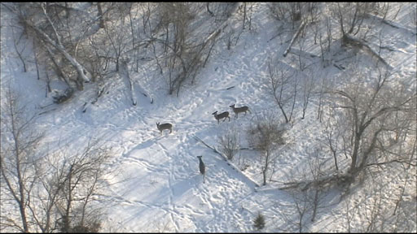In Canada, researchers conducted an aerial survey with a double-count technique to evaluate the white-tailed deer populations in twelve hunting zones. They flew in predetermined straight lines using coordinates on the Global Positioning System (GPS). They had two people that spotted deer in each strip and the data collected indicated that the aerial surveys were for the most part accurate. Even though they were able to capture an accurate population estimate with two people, they did indicate that by adding a third person, the data would be even more precise and less likely to be misinterpreted.

When conducting aerial surveys, the winter season is more ideal because there is less vegetation that prevents the spotters from locating deer. Overall, the estimations of white-tailed deer populations from using aerial survey methods are very comparable to road spotlight methods in open areas. The problem arises in the dense forests with large canopies. In these areas, population estimates are less likely to be expressed from utilizing aerial surveying methods due to the lack of open areas. Another factor to consider when differentiating between road spotlight counts and aerial counts is the cost. Aerial population surveys are more expensive and require an experienced piolet. This method is also dependent upon climatic factors, which can influence the reliability of this technique. Due to the strict procedures and requirements of the aerial survey method, it is most likely best to use this method on larger tracts of land with the majority of the landscape consisting of open grassland or open-canopied forests. Both aerial and road count surveys are useful wildlife management tools that should be considered when trying to decide how to estimate the white-tailed deer on a property.

**Fecal Pellet Counts** The fecal pellet count survey consists of multiple people walking transect lines and counting white-tailed deer fecal pellets. By slowing walking the transect lines and moving brush aside without disturbing the duff layer, pellets can be found either in clumps or split. It is important to refrain from bias in determining the transect lines. After the pellets have been counted, you can set up different models and indices to estimate the white-tailed deer density on the property. This survey method works great for properties that are in isolated areas and are hard to reach. Several research studies have been conducted comparing the accuracy of deer pellet counts to the actual current population.

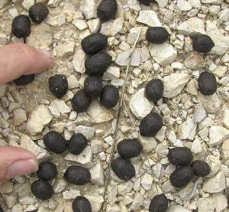One study, in particular, looked at the relationship between fecal pellet indices and deer density. In their research, they looked at 20 different enclosures to determine if pellet counts were a good indicator of the deer density. All of the surveyed enclosures were fenced in which prevented deer from moving freely throughout the study area. They used the Global Positioning System (GPS) to follow randomized transects throughout the enclosures. Then they evaluated the pellets found and based on several models were able to determine the deer density. After completing the study, the researchers concluded that deer densities can be evaluated by using a fecal pellet count survey. They did, however, suggest that deer movement might have been altered by the enclosures which may affect the accuracy of the survey method in the wild. Overall, this population survey method is fairly cost-effective but presents several problems. One of which is the difficulty of surveying large tracts of land. This survey method requires several people who can identify fecal pellets of white-tailed deer. Some landscapes make it hard to stay true to the predetermined transects and can cause the results to be skewed. This is a better method if the landowner wishes to survey smaller properties and can’t afford other survey methods. This method is cost effective and relatively easy to complete as long as the landowner or researcher has the time to complete the survey. In comparison to road spotlight surveys, this method requires more extensive time evaluating the data collects and requires a keen eye when distinguishing between deer fecal pellets and other mammals.

**Road Spotlight Survey** Road spotlight surveys are vastly used by most wildlife researchers and landowners who wish to estimate the white-tailed deer population on their property. This method is one of the oldest methods used by researchers and is proven to be successful in most situations to determine a rough estimate of the population. For this surveying method, landowners use a vehicle with four people and two spotlights. Two people spotlight deer depending on the predetermined route and the need for spotlights on both sides of the vehicle. One person will spotlight on each side of the vehicle while the other two people will record sightings from their designated spot lighter. Data is then collected on the sex of the deer spotted as well as the number of deer in each area. Depending on the size of the property, the landowner should split the property into several sections in order to gain a more accurate estimate. A route also should be designed on different roads throughout the property. As mentioned above, this can create bias because routes are often based off of convenience. It is important to refrain from bias and create a route that reduces the effects of bias on the data.

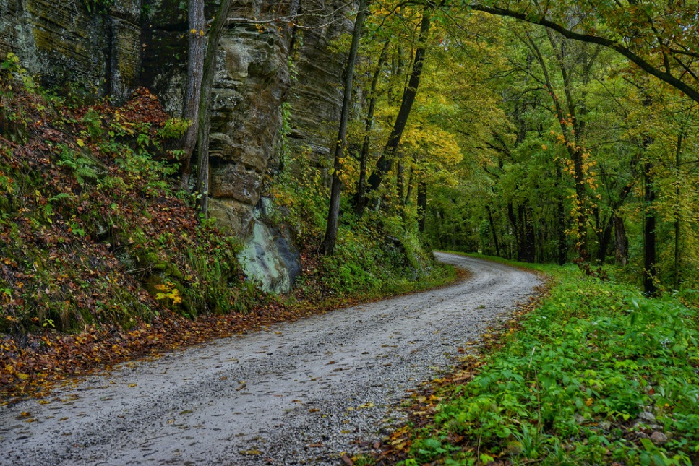After a route is established, researchers can drive the route and count the number of white-tailed deer in each section. It is crucial that the data is collected only on the route going in so that deer are not double counted. This can cause the estimates to be higher and affect the land managers harvest goals negatively. Some problems with this survey include the reliance on spotlights. Some spotlights are brighter than others which can allow the spotter to identify more deer while other spotlights are dimmer preventing the spotter from identifying deer. Another common mistake researchers make is misidentifying the sex of deer and the number. Deer often move when disturbed by the spotlights and an oncoming vehicle which becomes problematic when trying to identify the deer from a moving vehicle. This is why it becomes important for the landowner to have people who can identify deer well with bright spotlights conduct the research. Having two extra people who can help identify deer with binoculars is also a benefit when trying to accurately determine the deer sex ratios on the property. Because this method is relatively inexpensive and easy to use, it is a great management tool used by landowners and researchers. This method is better for properties with numerous roads established and open areas along the roadways. Deciduous forests become problematic because deer cannot be identified because of the thick vegetation.

**Conclusion** So to wrap things up, as landowners there are several techniques that we can use in order to survey population densities of white-tailed deer. We hope that this information encourages our readers to survey the white-tailed deer populations on their property this year. Using one of these surveying methods can be an important tool in the tool belt for all landowners. It is important to conduct careful research and plan out each survey regardless of the type of survey method used. With a little time and effort, every landowner can manage their deer herds effectively. We hope that this information was helpful to all of our readers, and we look forward to providing more information on habitat management in the future.

**Literature Cited**

Collier, Bret A., et al. "Detection Probability and Sources of Variation in White-Tailed Deer Spotlight Surveys." *Journal of Wildlife Management*, vol. 71, no. 1, 2007, pp. 277-281*.*

Collier, Bret A., et al. "Spotlight Surveys for White-Tailed Deer: Monitoring Panacea Or Exercise in Futility?" *Journal of Wildlife Management*, vol. 77, no. 1, 2013, pp. 165-171*.*

Forsyth, David M., et al. "Modeling the Relationship between Fecal Pellet Indices and Deer Density." *Journal of Wildlife Management*, vol. 71, no. 3, 2007, pp. 964-970*.*

Potvin, François, Laurier Breton, and Louis-Paul Rivest. "Aerial Surveys for White-Tailed Deer with the Double-Count Technique in Québec: Two 5-Year Plans Completed." *Wildlife Society Bulletin*, vol. 32, no. 4, 2004, pp. 1099-1107*.*

Roberts, Clay W., et al. "Comparison of Camera and Road Survey Estimates for White-Tailed Deer." *Journal of Wildlife Management*, vol. 70, no. 1, 2006, pp. 263-267*.*



**Big Tine Consulting Inc.**

**Point Lookout, MO**

**Email: BigTineConsulting@msn.com**

**Phone: (417)-794-2653**

**Website: BigTineConsulting.wordpress.com**